A+ Computer Science IFS – Spiral Maze Lab Value - 100

Lab Goal: This lab was designed to help you review loops and to learn more about how you can combine loops and ifs to solve problems. You must determine how and when to turn, and most importantly when to stop. You must create if commands based on the requirements of this problem. Pay close attention – it will only require a few basic decisions if you take a careful look at the decisions that need to be made.
Lab Description: This lab requires that you use looping with if statements. Your Jeroo must make its way through the entire maze and stop before jumping into the water. You should be able to make the Jeroo spiral in to the center and then spiral back out to the start.
Files Needed:
sprialmaze.jsc
SpiralMazeIsland1.jev
SpiralMazeIsland2.jev
SpiralMazeIsland3.jev

Starting Screen:
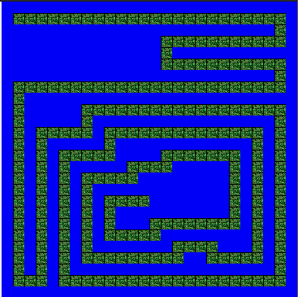
algorithm help

Preconditions
- I am facing the path?
- Is it clear to move ahead?
- Do I turn left or right?
- Should I stop?

Postcondition
- Successful hop through the maze
- Jeroo is not in the water
- Jeroo is facing West
- Jeroo stops facing the water.

Solve it using recursion for extra credit!!!!!

Ending Screen:
